Now available on CD disk.
Aboriginal fringe dwellers in
Darwin:
Cultural persistence or a culture of resistance?
By William Bartlett Day
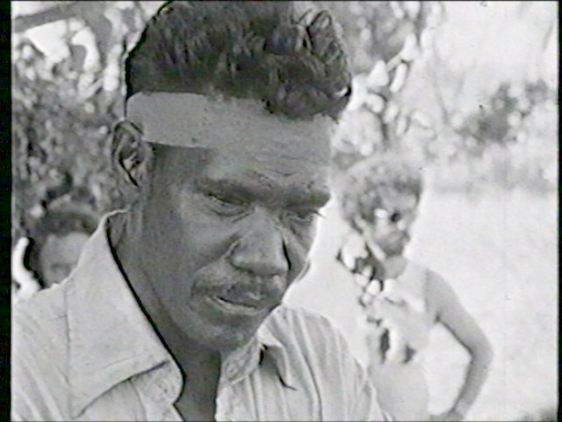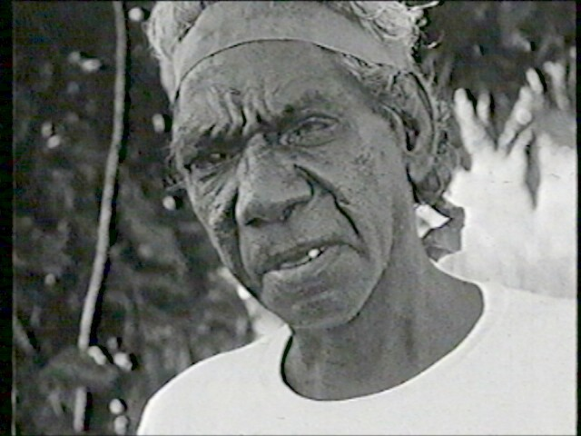
Above: Major Bangun of Knuckeys Lagoon; Bobby Secretary of Kulaluk - Darwin, 1973
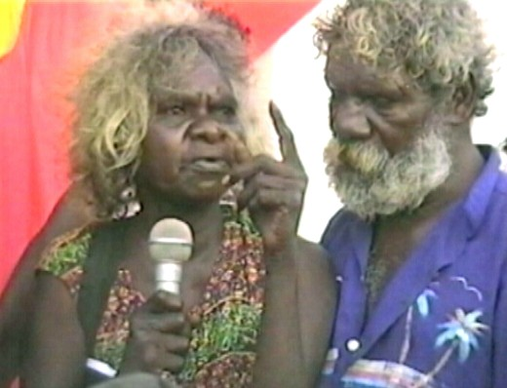
Above: Dulcie Malimara and George Banbuma - Darwin 2001
PhD Thesis for the Department of Anthropology, UWA
Submitted 2001
This copy reprinted 2006

